Instructions on how to register as a new runner:

1. Sign up for a new account or sign in to New York Road Runners
​
2. When you get to Step 3 of registration, select New York County Dental Society as your Running Club.
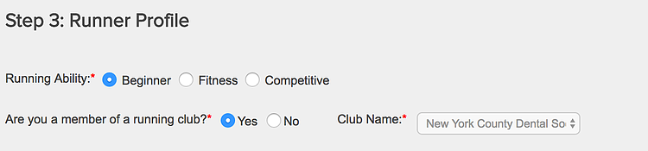

3. Once you sign in, click My NYRR on the top menu. It will be in orange on the upper right corner.
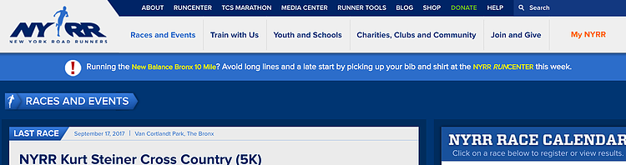

4. Click on the Races and Registration tab on the left side of your page and then add Japan 4M to your cart.
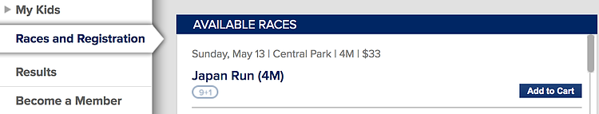

5. Follow the instructions for registration to complete your application.

6. For the Manhattan 7 Mile, please email Dr. Michael Cote at cote@nyu.edu to confirm your participation. For Grete’s Great Gallop, please email Dr. Steven Moss at stevenmossdds@gmail.com to confirm your participation. For Race to Deliver, please email Dr. Kenneth Cooperman at drken@tribecateeth.com to confirm your participation.

